**Report on Soft Computing Techniques**

**Topic**

Design & Implement Neural network models (Perceprton,SVM,LVQ,SOM) on Online Shoppers Purchasing Intention Dataset

Submitted to

Dr. Aditya Khamparia

Submitted by

Saundarya Modak

Reg.No. 11806505



Neural Network Models

# Perceptron

Perceptron are Binary Classifiers (0/1), we can define their computation as follows:

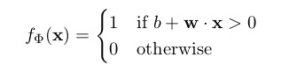

Base Algorithm of perceptron:

1. set b = w = 0  
2. for N iterations, or until weights do not change  
(a) for each training example xᵏ with label yᵏ  
i. if yᵏ — f(xᵏ) = 0, continue  
ii. else, update wᵢ, △wᵢ = (yᵏ — f(xᵏ)) xᵢ

# **Support Vector Machine (SVM)**

SVM Model Expressed Mathematically

Image for post

It is a supervised machine learning algorithm used for binary classification problems.

# **Learning vector quantization (LVQ)**

LVQ is a so-called prototype-based learning method. One or more prototypes are used to represent each class in the dataset, each prototype is described as a point in the feature space. New (unknown) datapoints are then assigned the class of the prototype that is nearest to them. In order for “nearest” to make sense, a distance measure has to be defined.

# **Self-Organizing Maps (SOM)**

The main objective of SOMs is to transform a complex high dimensional discrete input space into a simpler low-dimensional discrete output space by preserving the topology in the data but not the actual distances. It is an unsupervised learning algorithm which uses simple heuristic method capable of discovering hidden non-linear structure in high dimensional data.

## Dataset

Dataset plays the most important role in any machine learning algorithms. Just like humans needs their eyes and sense organs to observe the things happening around and recognizing the pattern, similarly dataset is fed to networks and machine recognizes the pattern.

Data file consists of various Information related to customer behavior in online shopping websites.

<https://www.kaggle.com/roshansharma/online-shoppers-intention>

**Screenshots of Output**

Perceptron

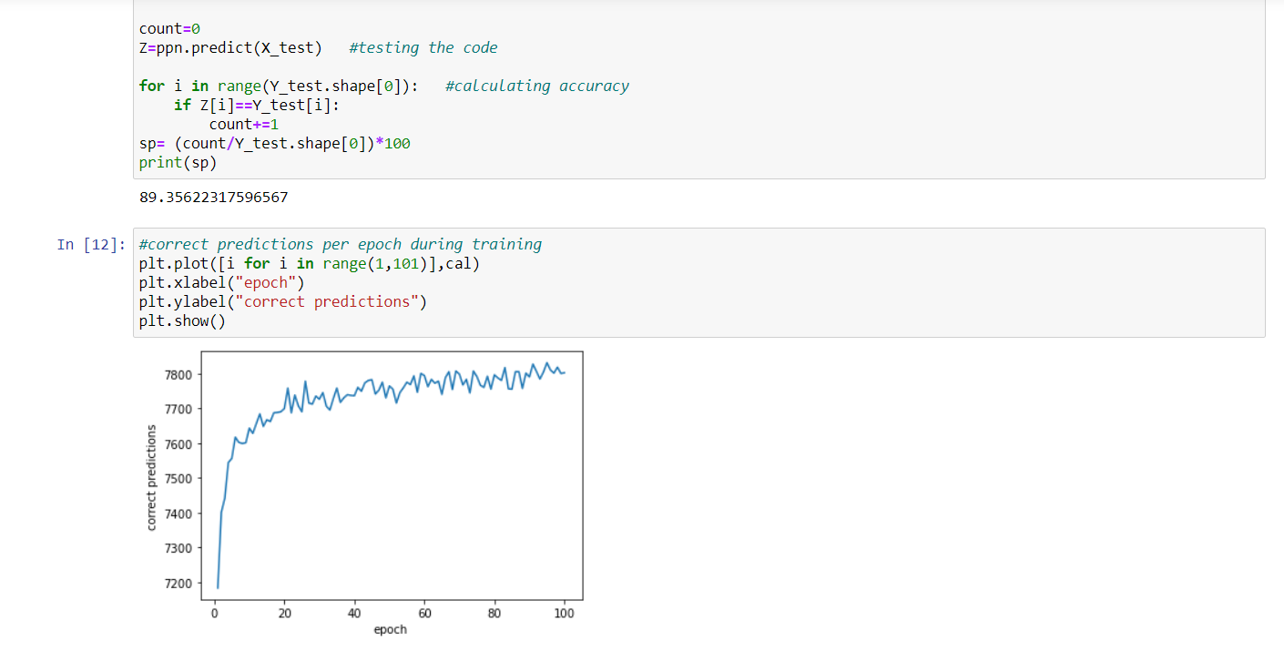

LVQ

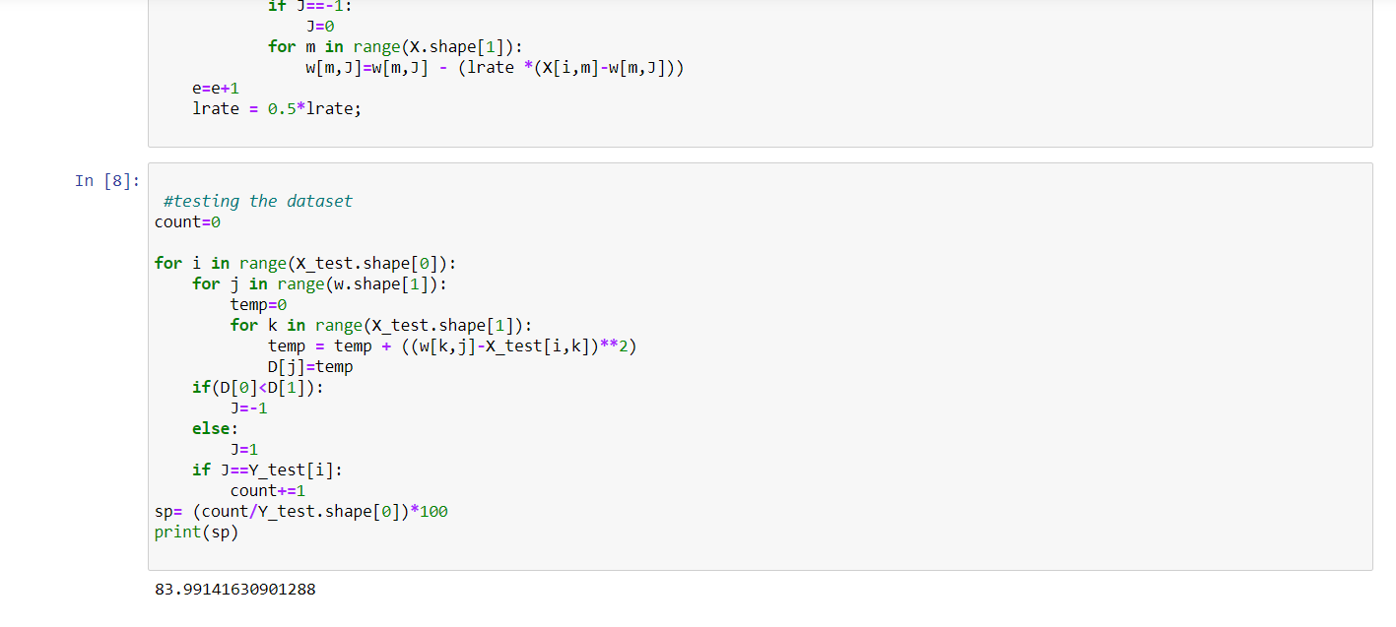

SOM

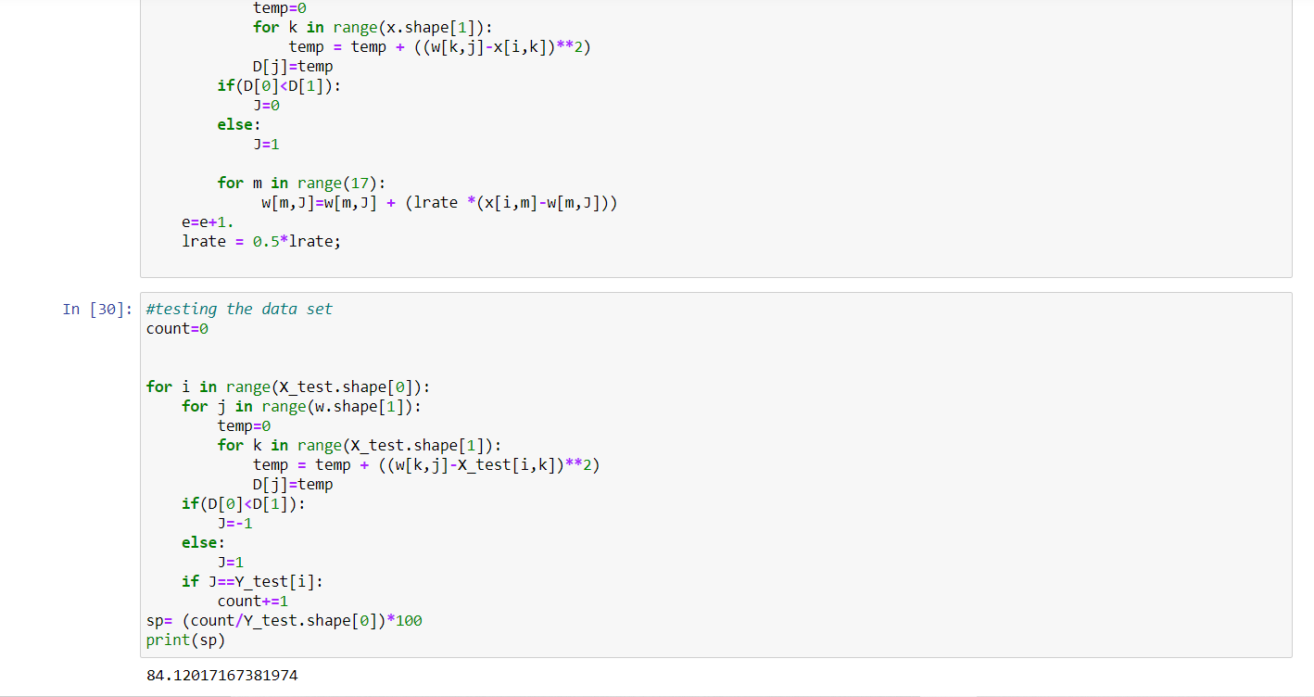

SVQ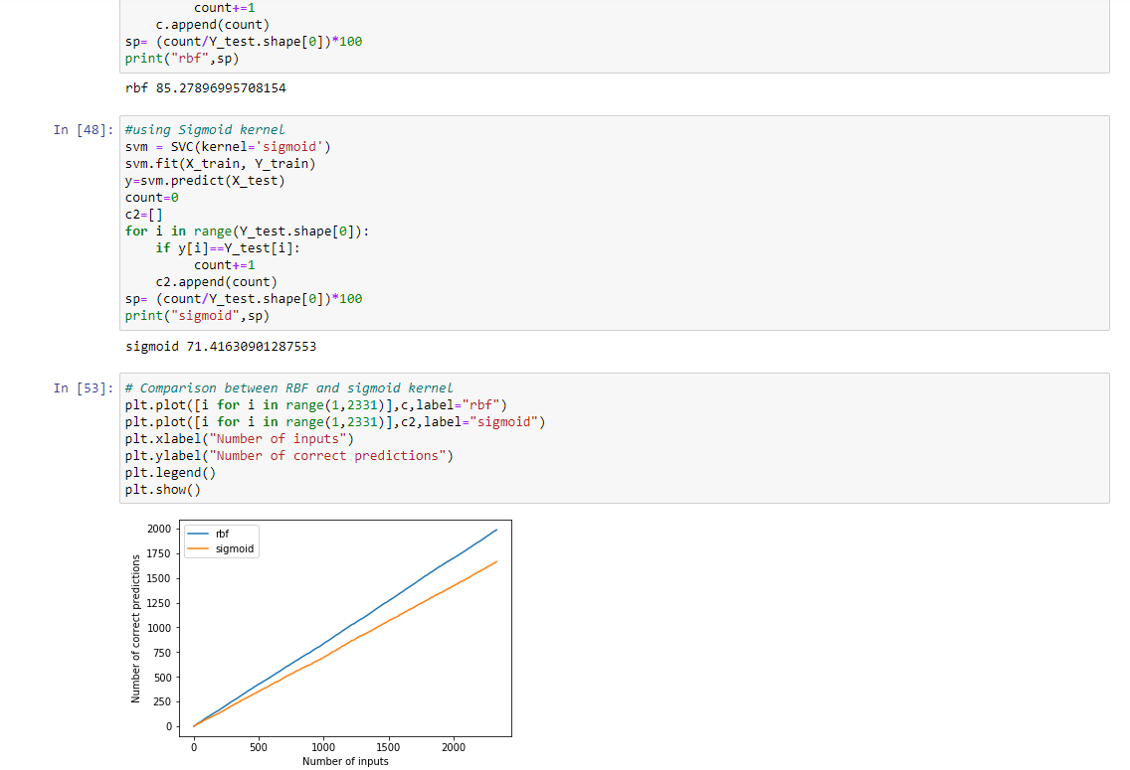

# References

* <https://analyticsindiamag.com/understanding-the-basics-of-svm-with-example-and-python-implementation/>
* <https://towardsdatascience.com/svm-implementation-from-scratch-python-2db2fc52e5c2>
* <https://towardsdatascience.com/learning-vector-quantization-ed825f8c807d>
* <https://machinelearningmastery.com/implement-perceptron-algorithm-scratch-python/>